Technical Diction

⚙️ What is Technical Diction
# Source: Chatgpt (GPT-4-turbo) at [7/30/2025]
Technical diction involves the use of precise, domain-specific language used to convey factual or instructional information in fields such as science, engineering, law, medicine, IT, and more.
It overlaps with jargon but is primarily used for clarity, instruction, and accuracy, often in formal and structured writing.

✅ Key Features:
# Source: Chatgpt (GPT-4-turbo) at [7/30/2025]
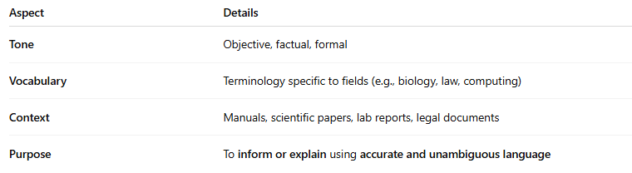
Aspect | Details
Tone | Objective, factual, formal
Vocabulary | Terminology specific to fields (e.g., biology, law, computing)
Context | Manuals, scientific papers, lab reports, legal documents
Purpose | To inform or explain using accurate and unambiguous language

🧠 Examples of Technical Diction:
# Source: Chatgpt (GPT-4-turbo) at [7/30/2025]
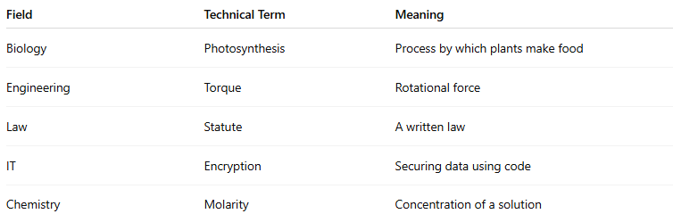
Field | Technical Term | Meaning
Biology | Photosynthesis | Process by which plants make food
Engineering | Torque | Rotational force
Law | Statute | A written law
IT | Encryption | Securing data using code
Chemistry | Molarity | Concentration of a solution

✍️ Example Sentences Using Technical Diction:
# Source: Chatgpt (GPT-4-turbo) at [7/30/2025]
- “The solution had a molarity of 0.5 M, indicating a moderate concentration of solute.”
- “The algorithm optimizes resource allocation through dynamic programming techniques.”

🆚 Technical Diction vs Jargon Diction:
# Source: Chatgpt (GPT-4-turbo) at [7/30/2025]
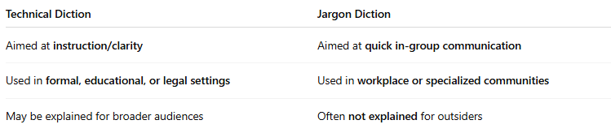
Technical Diction | Jargon Diction
Aimed at instruction/clarity | Aimed at quick in-group communication
Used in formal, educational, or legal settings | Used in workplace or specialized communities
May be explained for broader audiences | Often not explained for outsiders

🧭 Used In:
# Source: Chatgpt (GPT-4-turbo) at [7/30/2025]
- Academic and scientific texts
- Instruction manuals
- Professional reports
- Policy documents
- Medical and legal literature

